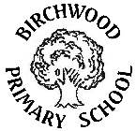**Curriculum Information**

**Summer 2 Year 3**

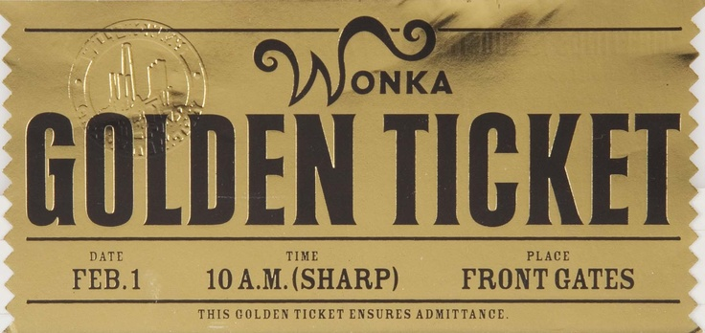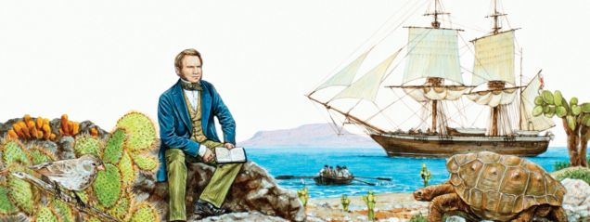

**Our topic this half term is ‘Scrumdiddlyumptious’.**

What a tasty topic this one is! All of Year Three have a golden ticket to take a journey with Mr Willy Wonka as he endeavours to turn his chocolate factory into an equally delicious yet healthier option. We must try, test and sell our healthy product ideas to ensure they are worthy enough to be sold and created by his trusty Oompa Loompas.

**As writers**, we will be writing instructions, character descriptions, setting descriptions and alternative story endings.

**As readers**, we will read Charlie and the Chocolate Factory. The story of Charlie Bucket and his Golden Ticket, and Willy Wonka and his amazing chocolate factory. Mr Willy Wonka, the most wondrous inventor in the world, opens his gates of his amazing chocolate factory to five lucky children.

**In Maths,** we will learn about measures, multiplication and division and explore calculation strategies and place value.

**In Science,** we will find out about animals, including humans, why they have skeletons and how skeletons differ in different animals.

**In Art,** we will be exploring the work of Quentin Blake.

**In Computing,** we will be using block coding and explaining the risk of talking to unknown people online.

**In Design and Technology**, we will creating shell structures using computer aided design.

**In Geography,** we will be learning about food distributing countries and Fair Trade food.

**In Languages,** we will be speaking, listening and writing about asking questions.

**In Music,** we will play an ostinati on untuned percussion as part of an accompaniment to a song.

**In PSHE,** we will learn about healthy lifestyles and growing and changes.

**In PE,** we will be taking part in athletics. Oak 3 will be swimming and Maple 3 will be taking part in Outdoor Adventurous Activity.

**In RE,** we will learn about Muslim beliefs and celebrations.

|  |
| --- |
|  |