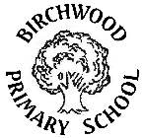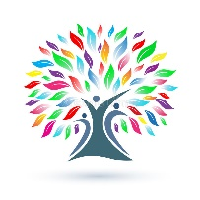**Curriculum Information**

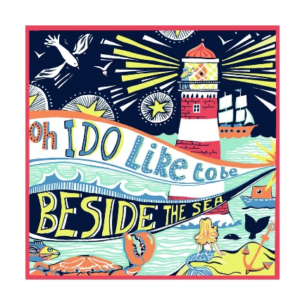**Summer 2 Year 2**

**Our topic this half term is ‘Beside the Seaside.’**

Grab your bucket and spade and let’s head to the coast! At the beach, we will learn about the physical and human features that can be found and explore how life in a coastal town compares to life in Tamworth. As an island we are surrounded by the sea so we will take a closer look at which seas specifically surround the United Kingdom and how to stay safe when we are near water.

**As writers**, we will use our key texts to write diary entries about the exciting adventures had by beach goers, write instructions for our DT recipe as well as write a persuasive letter to help the inhabitants of Blackrock.

**As readers**, we will read non-fiction texts about lighthouses to help improve our vocabulary and read wonderful stories about the seaside to make predictions and explore hidden meanings in wordless texts.

**In Maths,** we will focus on measuring mass in grams and kilograms and explore calculation methods in addition, subtraction, multiplication and division.

**In Science,** we will learn about plants and explore the conditions needed to help a seed germinate and grow healthily.

**In Computing,** we will recall all of our known knowledge for keeping safe and learn all about coding at the appropriate level.

**In Art**, we will evaluate the work of sculptor, Courtney Mattison, who creates fantastic clay artworks depicting the erosion of the world’s coral reefs. We will explore ways to manipulate clay for our own piece in Mattison’s style.

**In History,** we will be look at the significant event that lead up to and followed the heroic acts of Grace Darling.

**In Music,** we will be rehearsing for our Year 2 class assembly and compose using stick notation for crochets and quavers.

**In PSHE,** we will learn how to stay safe near water and in the sun as well as finding ways to manage our feelings when we experience change such as moving to Year 3.

**In PE,** we will take part in athletics and gymnastics.

**In RE,** we will reflect and celebrate our differences. We will also learn about Islam and the story ‘The Prophet and the Ants’.