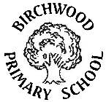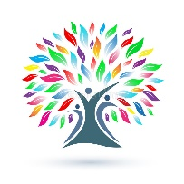**Curriculum Information**

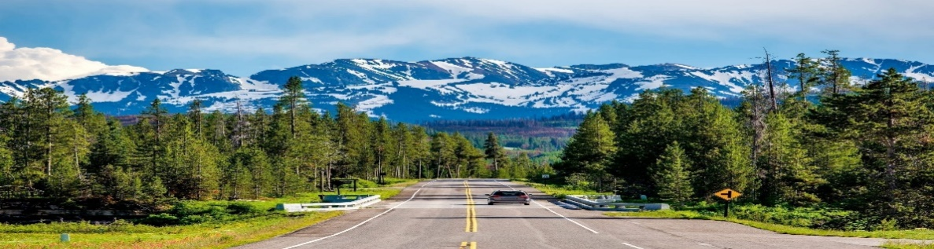**Autumn 1 Year 3**

**Our topic this half term is ‘Road Trip USA’**

Year 3 have are all set to go on a road trip around the USA and to learn about the different States. Along the way, we will research iconic American people, make traditional American dishes and identify physical and human features of North America. We will have a go at designing and building our own bridges after finding out about the world famous Golden Gate Bridge.

**As writers**, we will be writing a character description, a story, a diary entry and a setting description.

**As readers**, we will read ‘Snow White in New York’, ‘After the Fall’ and ‘Bill’s New Frock’

**In Maths,** we will learn about number sense and exploring calculations strategies, place value and graphs.

**In Science,** we will find out about how plants grow and how seed dispersal occurs.

**In Art,** we will be learning about the American architect Frank Lloyd Wright and how he was inspired by nature and geometric shapes.

**In Computing,** we will be identifying the input, processes and output of computers. We will be learning how computers networks can be used to share information. We will know the key components of a network.

**In Design and Technology,** we will be designing, building and evaluating our own bridges.

**In Geography,** we will be discovering New York and North America. We will be locating New York and finding out about its physical and human features. We will also learn about the hemispheres and 4 & 6 figure grid references.

|  |
| --- |
|  |

**In Languages,** we will be speaking, listening and writing about numbers up to 10, colours and greetings.

**In Music,** we will show the shape of the tune with our voiced when singing and add an accompaniment using notes from the pentatonic scale. We will invent 3-note melodies to accompany our singing.

**In PSHE,** we will learn about protective behaviours and health & wellbeing.

**In PE,** Maple class will be having swimming lessons and Oak class will be taking part in outdoor adventurous activities and the whole year group will also be doing dance.

**In RE,** we will learn about Hinduism, Braham and the Creation of the World.