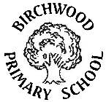**Curriculum Information**

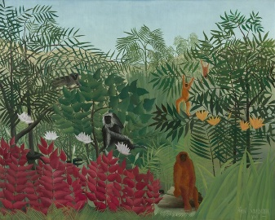**Spring 2 Year 2**

**Our topic this half term is ‘Under the Canopy’**

Can you help save the orang-utan’s home from being destroyed?

This half term we are going to become rainforest experts by learning about some of the factors that lead to the harming of the rainforest. Some of the things we are going to be finding out about are living things and their habitats, pollution and sustainability.

**As writers**, we will be creating a piece of writing surrounding our trip to Stratford Butterfly Farm, and writing a non-chronological report all about orang-utans! We will continue with our Active Spelling lessons.

**As readers**, we will continue with our guided reading sessions. We will revise the VIPER skills during our guided reading written tasks.

**In Maths,** we will begin to learn about fractions of shapes and of quantities, we will add and subtract 2-digit numbers using regrouping and adjusting, and we will explore money.

**In Science,** we will learn about living things and their habitats.

**In Art,** we will be studying the artist Rousseau and his painting ‘Tiger in a Tropical Storm’, we will sketch leaves and create our own jungle painting.

**In Computing,** we will be creating a spreadsheet on Purple Mash, using graphs and totalling tools.

**In Design and Technology**, we will learn about palm oil and the effects of using this on the rainforest. We will be making an ‘Orang-utan friendly cereal bar’.

**In Music,** we will begin to learn about notation and dynamics whilst exploring pieces of music about trains.

**In PSHE,** our focus is on looking after the environment and understanding what pollution is and the effects of it on our planet.

**In PE,** we will take part in gymnastics; performing a range of balances, jumps and rolls. We will also take part in a variety of team games.

**In RE,** we will learn what Easter and The Resurrection mean to Christians.